Importing project packages in Unity

Introduction
This document will describe what steps need to be taken to successfully import the project’s packages into Unity, as they are excluded from the git repository.

Process
The picture in Figure 1 is what the project looks like when you open it for the first time.
There are 59 errors, all indicating a missing namespace.
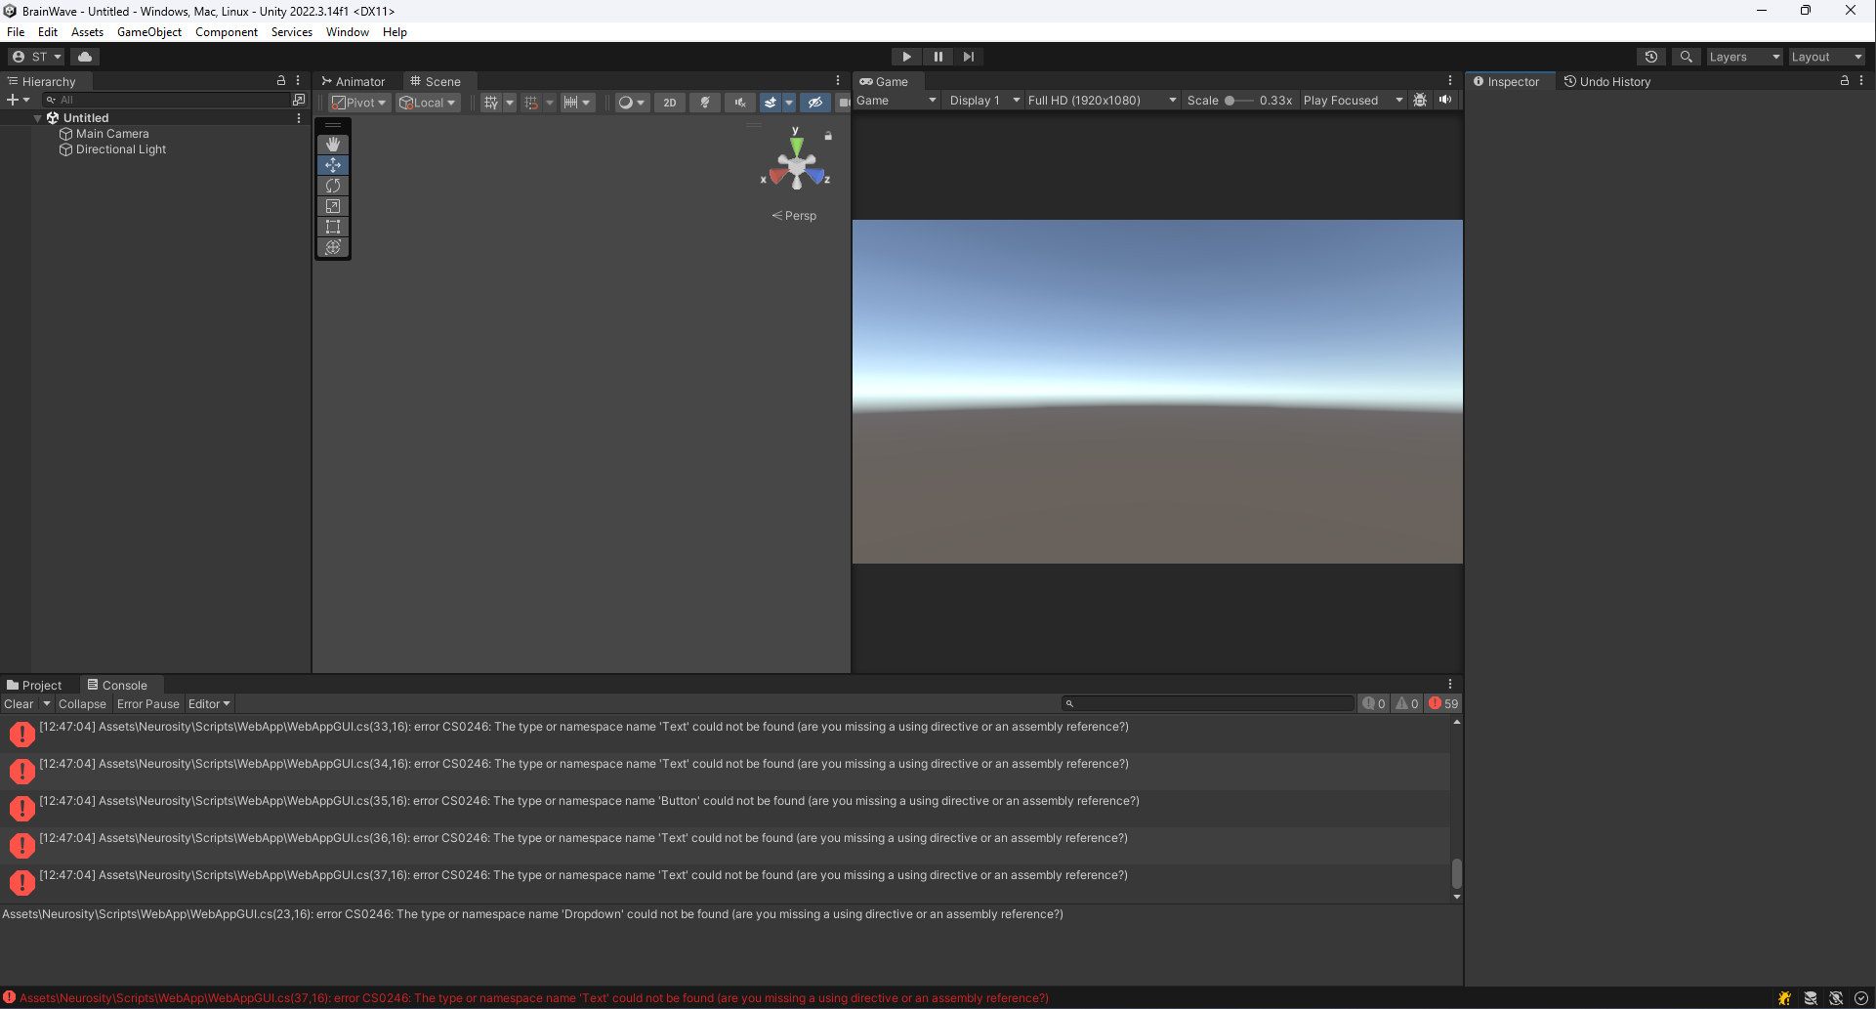
Figure 1: Startup.

Go to https://developers.google.com/unity/archive.
Search (ctrl + F) “com.google.firebase.database”.
Download the files from version 11.5.0 within the red rectangle seen in Figure 2.
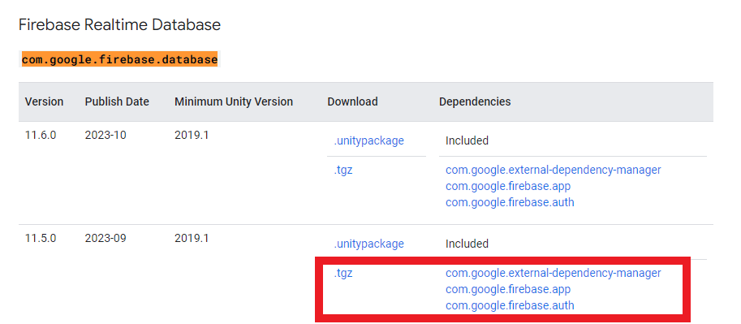
Figure 2: Files to download.

In Unity, open Window -> Package Manager.
The packages can be added by “Add package from tarball…”, shown in Figure 3.
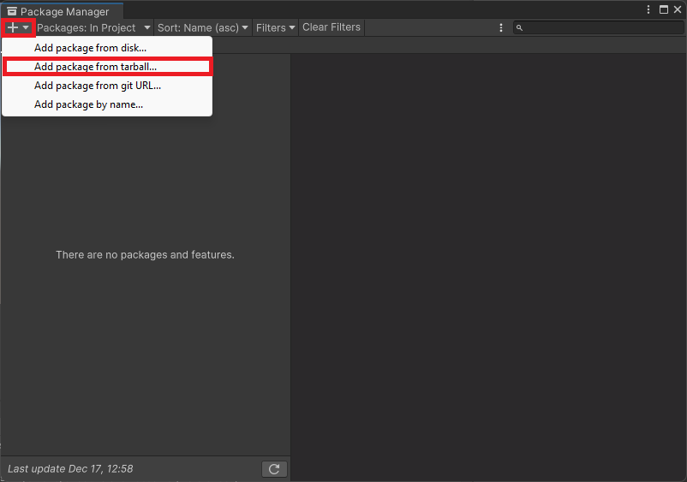
Figure 3: Add package from tarball.
The packages must be imported in a specific order, seen in Figure 4:
- “com.google.external-dependancy-manager-1.2.177.tgz”
- “com.google.firebase.app-11.5.0.tgz”
- “com.google.firebase.auth-11.5.0.tgz”
- “com.google.firebase.database-11.5.0.tgz”
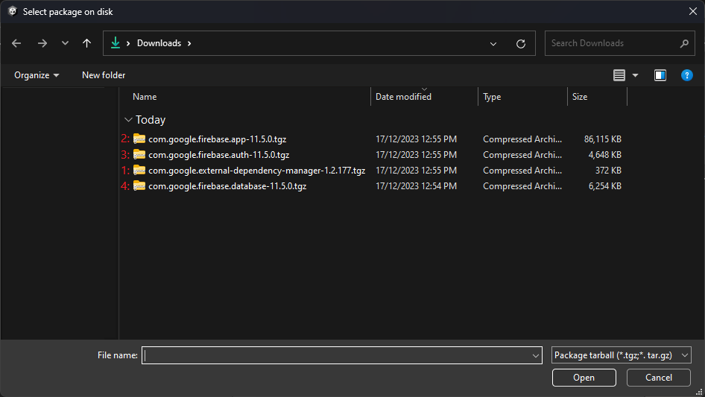
Figure 4: Firebase package import order.

The project requires Newtonsoft for json conversion, which can be added by “Add package from git URL…”, shown in Figure 5.
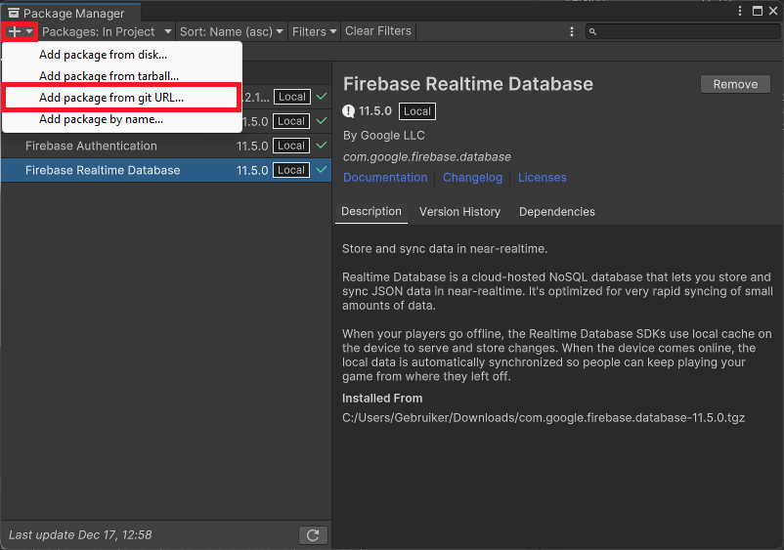
Figure 5: Add package from git URL.
Enter the following url: “com.unity.nuget.newtonsoft-json”.

The Package Manager window should now look like Figure 6.
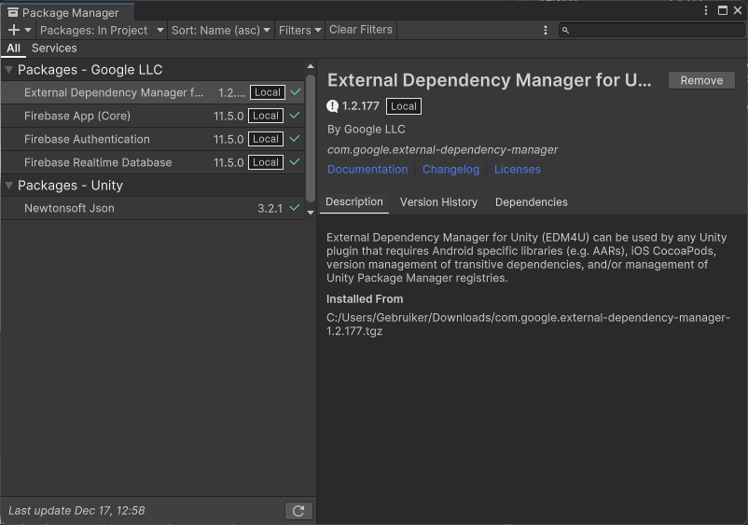
Figure 6: Package Manager window.

Finally, the Input System, Unity UI, Universal RP, TextMeshPro, and Cinemachine packages need to be installed.
These can be searched in the Unity Registry as seen in Figure 7.
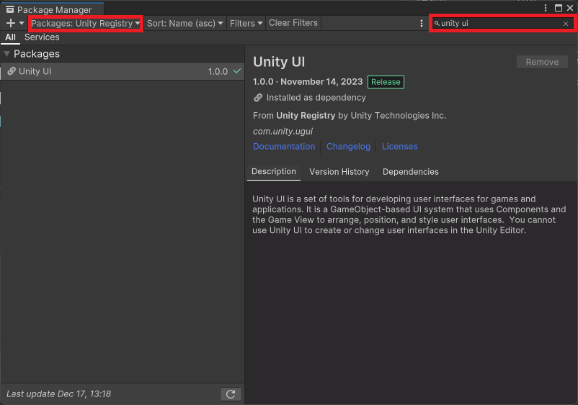
Figure 7: Search Unity UI in Package Manager.
During the development, the team will use Visual Studio.
To generate the project files, “Engineering” must also be imported, which can be done the same way as the previous packages, shown in Figure 7..

The Package Manager window after all the packages have been imported should look like Figure 8.
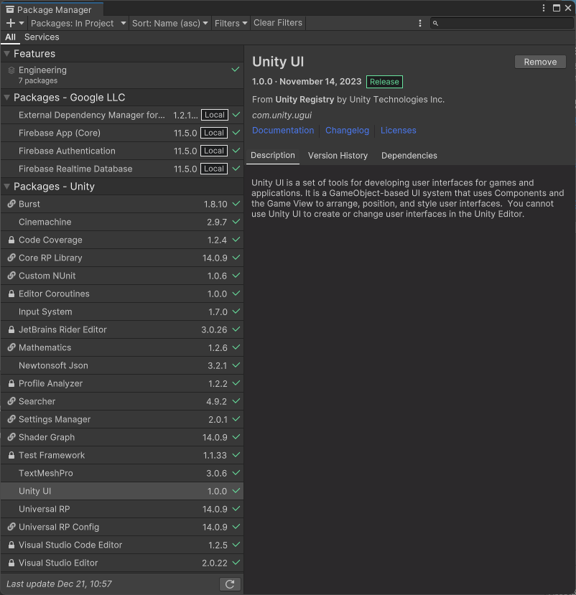
Figure 8: Full Package Manager window.

When the Solution Explorer in Visual Studio is not working properly, go to Edit -> Preferences -> External Tools, and make sure Visual Studio is selected, then click “Regenerate project files”.
The Solution Explorer should then look like Figure 9.
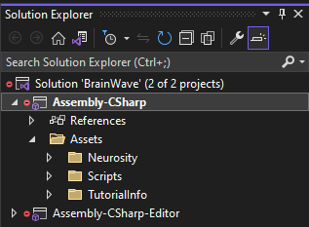
Figure 9: Solution Explorer.

